Packet Tracer – Configuring RIPv2

Topology

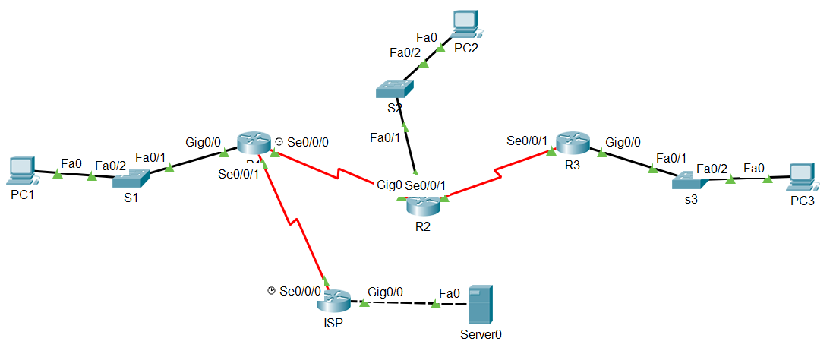

**192.168.5.0/24**

**192.168.1.0/24**

**192.168.2.0/24**

**192.168.3.0/24**

.1

.10

**64.100.0.0/8**

**209.165.200.0/30**

**192.168.4.0/24**

## Addressing Table

|  |  |  |  |  |
| --- | --- | --- | --- | --- |
| **Device** | **Interface** | **IP Address** | **Subnet Mask** | **Default Gateway** |
| **R1** | **G0/0** | 192.168.1.1 | 255.255.255.0 | N/A |
| **S0/0/0** | 192.168.2.1 | 255.255.255.0 | N/A |
| **S0/0/1** | 209.165.200.2 | 255.255.255.255 | N/A |
| **R2** | **G0/0** | 192.168.3.1 | 255.255.255.0 | N/A |
| **S0/0/0** | 192.168.4.1 | 255.255.255.0 | N/A |
| **S0/0/1** | 192.168.2.2 | 255.255.255.0 | N/A |
| **R3** | **G0/0** | 192.168.5.1 | 255.255.255.0 | N/A |
| **S0/0/1** | 192.168.4.2 | 255.255.255.0 | N/A |
| **ISP** | **S0/0/0** | 209.165.200.1 | 255.255.255.255 | N/A |
| **G0/0** | 64.100.0.1 | 255.0.0.0 | N/A |
| **Web Server** | **NIC** | 64.100.0.10 | 255.0.0.0 | 64.100.0.1 |
| **PC1** | **NIC** | 192.168.1.2 | 255.255.255.0 | 192.168.1.1 |
| **PC2** | **NIC** | 192.168.3.2 | 255.255.255.0 | 192.168.3.1 |
| **PC3** | **NIC** | 192.168.5.2 | 255.255.255.0 | 192.168.5.1 |

1. Objectives

Part 1: Configure Static Route from ISP to internal networks

Part 2: Configure RIPv2

Part 3: Verify Configurations

1. Background

Although RIP is rarely used in modern networks, it is useful as a foundation for understanding basic network routing. In this activity, you will configure a default route, RIP version 2, with appropriate network statements and passive interfaces, and verify full connectivity.

1. Configure a Summary Static Route from ISP to internal networks.

We could configure a static route on ISP for the internal networks. Because these networks are so close together, we can summarize them into one route. Again, doing this helps reduce the size of routing tables, which makes the route lookup process more efficient.

Looking at the three networks at the binary level, we can a common boundary at the **21th** bit from the left.

192.168.1.0 11000000.10101000.00000001.00000000

192.168.2.0 11000000.10101000.00000010.00000000

192.168.3.0 11000000.10101000.00000011.00000000

192.168.4.0 11000000.10101000.00000100.00000000

192.168.5.0 11000000.10101000.00000101.00000000

The prefix portion will include 192.168.0.0, because this would be the prefix if we turned off all the bits to the right of the 21th bit.

Prefix 192.168.0.0

To mask the first 21 left-most bits, we use a mask with 21 bits turned on from left to right:

Bit Mask 11111111.11111111.11111000.00000000

This mask, in dotted-decimal format, is...

Mask 255.255.248.0

Configure the summary static route on the ISP router.

The network to be used in the summary route is 192.168.0.0/21.

ISP(config)#**ip route 192.168.0.0 255.255.248.0 209.165.200.2**

1. Configure RIPv2
   1. Configure RIPv2 on R1.
      1. Use the appropriate command to create a default route on **R1** for all Internet traffic to exit the network through S0/0/1.

R1(config)# **ip route 0.0.0.0 0.0.0.0 s0/0/1**

* + 1. Enter RIP protocol configuration mode.

R1(config)# router rip

* + 1. Use version 2 of the RIP protocol and disable the summarization of networks.

R1(config-router)# version 2

R1(config-router)# no auto-summary

* + 1. Configure RIP for the networks that connect to **R1**.

R1(config-router)# network 192.168.1.0

R1(config-router)# network 192.168.2.0

* + 1. Configure the LAN port that contains no routers so that it does not send out any routing information.

R1(config-router)# passive-interface gig 0/0

* + 1. Advertise the default route configured in step 1a with other RIP routers.

R1(config-router)# default-information originate

* + 1. Save the configuration.
  1. Configure RIPv2 on R2.
     1. Enter RIP protocol configuration mode.

R2(config)# **router rip**

* + 1. Use version 2 of the RIP protocol and disable the summarization of networks.

R2(config-router)# **version 2**

R2(config-router)# **no auto-summary**

* + 1. Configure RIP for the networks directly connected to **R2**.

R2(config-router)# **network 192.168.2.0**

R2(config-router)# **network 192.168.3.0**

R2(config-router)# **network 192.168.4.0**

* + 1. Configure the interface that contains no routers so that it does not send out routing information.

R2(config-router)# **passive-interface gig 0/0**

* + 1. Save the configuration.
  1. Configure RIPv2 on R3

Repeat Step 2 on **R3**.

R3(config)# **router rip**

R3(config-router)# **version 2**

R3(config-router)# **no auto-summary**

R3(config-router)# **network 192.168.4.0**

R3(config-router)# **network 192.168.5.0**

R3(config-router)# **passive-interface gig 0/0**

1. Verify Configurations
   1. View routing tables of R1, R2, and R3.
      1. Use the appropriate command to show the routing table of **R1**. RIP (R) now appears with connected (C) and local (L) routes in the routing table. All networks have an entry. You also see a default route listed.
      2. View the routing tables for **R2** and **R3**. Notice that each router has a full listing of all the 192.168.x.0 networks and a default route.
   2. Verify full connectivity to all destinations.

Every device should now be able to ping every other device inside the network. In addition, all devices should be able to ping the **Web Server**.